VERSION NO.  0 0 0 9 | ROLL NUMBER

Name of candidate__________________

Sign. of Candidate_________________

Sign. of Invigilator_________________

BIOLOGY (HSSC-I)
SECTION –A (Marks: 17) Time Allowed: 25 Min
Note: Section – A is compulsory. All parts of this section are to be answered on this page and handed over to the Centre Superintendent. Deleting/overwriting is not allowed. Do not use lead pencil.

Q.1 Fill the relevant bubble for each part. Each part carries one mark.
 | Questions | A | B | C |  | D | A | B | C | D
1. | How many nitrogen atoms are present in adenine? | 2 | 5 | 3 |  | 6
2. | Tongue is involved in all of the following except: | Selection | Mastication | Mixing |  | Swallowing
3. | Cocci forming irregular clusters are: | Streptococci | Diplococci | Staphylococci |  | Sabrina
4. | Non-hyphal unicellular fungi are called: | Yeast | Toadstools | Mushrooms |  | Fruiting  bodies
5. | ________ is the procedure that separates molecules on the basis of their size, shape, molecular weight and surface charge. | Centrifugation | Electrophoresis | Chromatography |  | Spectrophotometery
6. | The largest lymph duct called thoracic lymph duct drains into | Subclavian  Vein | Pulmonary  Vein | Renal Vein |  | Hepatic Portal Vein
7. | Viviparous animals are those in which | Internal  fertilization  with external development  in eggs | Internal fertilization with internal development inside female body | Internal fertilization and internal development followed by hatching of egg |  | External  fertilization  with external development
8. | The bond formed between glucose and fructose to form sucrose is | 1,4 Glycosidic Linkage | 1,6 Glycosidic Linkage | 1,2 Glycosidic Linkage |  | 1,3 Glycosidic Linkage
9. | During photorespiration, the glycolate is converted into glycine in a structure of cell called: | Golgi Bodies | Mitochondria | Glyoxisome | Peroxisome
10. | ________is the yeast that grows in the mucous membrane of mouth or vagina. | Candida  albicans | Aspergillus fumigatus | Saccharomyces  cerevisiae | Aspergillus ﬂavus
11. | Circinate vernation is important feature of? | Club mosses | Whish ferns | Horse tails | Ferns
12. | These are highly evolved of all plants on the earth | Bryophytes | Pteridyophytes | Gymnosperms | Angiosperms
13. | Nucleoproteins found in | Hormones | Egg yolk | Chromosomes | Milk
14. | The diagram shows part of a molecule of a carbohydrate formed by glucose  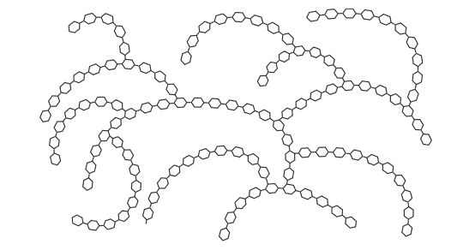  What is the name of the molecule? | Amylose | cellulose | Glycogen | Chitin
15. | The diagram shows an electronmicrograph of a typical animal cell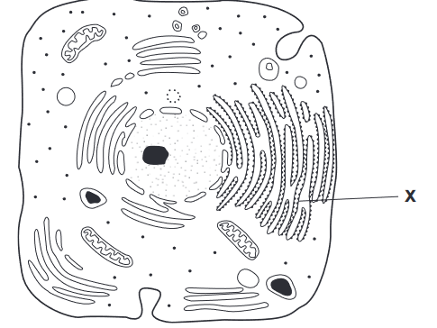  What is the function of the membrane system labelled X? | lipid synthesis | lipid synthesis and transport | protein synthesis | protein synthesis and transport
16. | In case of a snake bite when you treat a person by Antivenom serum which type of immunity is provided by this action? | Humoral immune response | Passive immunity | Active immunity | naturally induced immunity
17. | These cells also  release lysosome  enzymes  that kill  microorganisms? | Neutrophils | Lymphocytes | Basophils | Monocytes
HCCS EDUCATIONAL SYSTEM
BIOLOGY HSSC I
(PRE BOARD EXAM, 2024)
(SUBJECTIVE)
Time allowed: 2:35 Hours Total Marks Section B and C: 68
Note: The Questions of sections B and C are to be answered on the separately provided answer book. Use supplementary answer sheet i.e. sheet – B if required. Write your answers neatly and legibly.
SECTION – B (42 Marks)
Q.2 Attempt all parts. All parts carry equal marks. (14 x 3 = 42)
1. Briefly discuss functions of micro bodies?
OR
What is the fate of H⁺ of photolysis in the process of photosynthesis?
2. Compare different types of RNA?
OR
Illustrate the formation of triacylglycerol?
3. Compare Lytic and Lysogenic cycle?
OR
Compare outer body structure of euglenoids, dinofalgellates and diatoms?
4. Discuss different growth phases in plants?
OR
Discuss structure of an artery?
5. Differentiate between cartilaginous and bony fishes?
OR
Write short note on role of k⁺ ions in the opening and closing of stomata?
6. Write short note on mode of action of NK cells?
OR
Write short note on role of lymphoid organ in circulatory system?
7. Differentiate between protostomes and deuterostomes?
OR
Discuss general characteristics of phylum hemichordates?
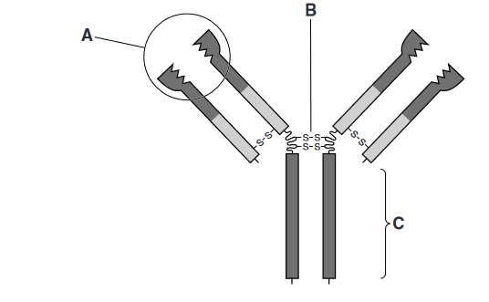
8. Antibodies against measles are produced by plasma cells during an immune response.
An antibody molecule is shown in the diagram
a. Explain the functions of the parts labelled
A, B and C
b. Write down the four mode of actions of antibodies

OR
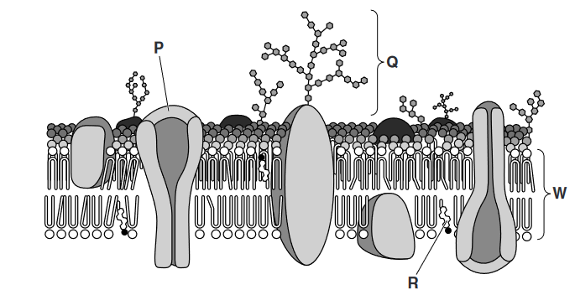
Cell membrane is the important boundary of a cell. A part of cell membrane shown in diagram
a. Write down the names of label part Q,P and R
b. Write down the functions of Q,P and R

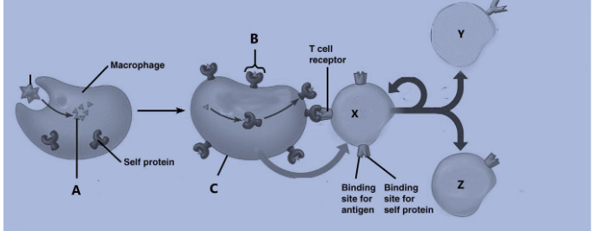
9. Keeping in mind the cell mediated immune response. Answer the following questions.
- Identify the structures A,B & C. Recognize the cell responsible for producing antibody?
- How the role of Y and Z is different from each other?
OR
What do you know about ECG and their use?
10. What are the roles of Abscisic acid and ethene in plants growth and development?
OR
Compare Apoplast, symplast and vacuolar pathway of water transport in plants?
11. Write down steps of evolution of multiple vein leave?
OR
Compare different groups of animal on the basis of body cavity
12. Compare the evolutionary adaptations of the given phyla:
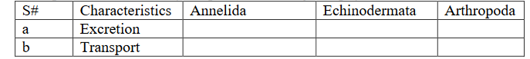
OR
Draw life cycle of physarum?
13. Differentiate between types of mycorrhizae?
OR
How the evolution of pollen tube took place? Explain its importance.
14. Compare endospore, exospore and cysts?
OR
Why kingdom Protista is called as polyphyletic group
SECTION – C (26 Marks)
NOTE: Attempt all questions. All questions carry equal marks.
Q. 1 Write detail note on life cycle of angiosperms plants.
OR
Discuss transport of food in plants with the help of pressure flow theory?

Q2.Write detail note on conducting system of Heart.
OR
Write detail note on structure of stomach.

Q3. Write detail note on structure of gram positive and gram negative bacterial cell wall?
OR
Write detail note on life cycle of HIV with the help of diagram?

Q4. Write detail note on ETC in mitochondrion?
OR
Write detail note on phylum Echinodermata.

